Dallas Theater Center Guild Newsletter

January 2011, Volume 2, Issue 2
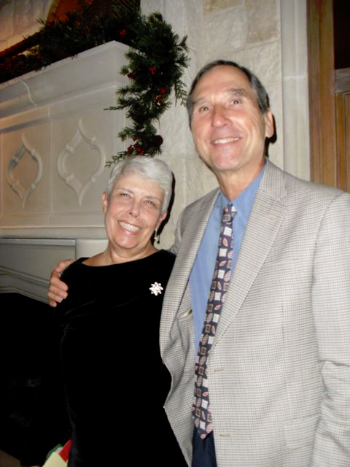

The Guild ended its 2010 year with a wonderful Christmas party hosted by Don and Sarah Warnecke. We auctioned off three items, two wreaths and an incredible chef-prepared dinner, to begin our fund raising efforts for the year. As we now move into 2011 we are excited to continue with our support of the Dallas Theater Center and anticipate the remaining performances of the season. Don’t forget to check the Theater’s web site (www.dallastheatercenter.org) for interesting information and promotions.

Our first Meet-and-Greet of the New Year was held at the Wyly Theatre on January 4th. Arsenic and Old Lace tech dinner is scheduled for January 30th at the Kalita Humphreys Theater. This will be followed by our General Meeting on January 31st, held at the Black Dance Theatre in the Arts District. We look forward to continuing our speakers’ forum “Hobnobbing with our Artsy Neighbors” for the General Meetings.

Our plans for 2011 also include offering another screenplay reading at the Kalita Humphreys Theater, following last year’s very successful reading of Preston Jones’s The Oldest Living Graduate from A Texas Trilogy. We also plan to kick off a Salon Series this spring. This series will provide yet another dimension for our live theater experience.

We would like to thank each and every one of you that contributed to all of the Guild activities last year and wish all a healthy and joyous New Year.

Karen and Jerry Zvonecek

Happy New Year from the DTC staff! We are thrilled to welcome 2011 and all of the opportunities it will bring.

But before we look forward, here’s a quick recap of what’s happened in the last few months of 2010. As we closed another year we said farewell to Mark Hadley, who will be sorely missed around the office. The staff bid him farewell with beer and ski-ball at Dave and Busters on his last week. Another internal change was made when Rachel Hull, who was Interim Director of Education, became the Director of Education. We are very excited for Rachel. In the words of Kevin Moriarty:

Rachel has been a great asset to our Education Department for many years, as a passionate advocate for the power of theater to transform students' lives, an energetic and fiercely committed collaborator with others, and as a dedicated and skilled teacher. In the past few months, as the Interim Education Director, it has become abundantly clear that she also posses the administrative skill, creative vision and leadership abilities to step into the department's leadership position.

So now we look to a new year of new leaders and new initiatives. Much of the buzz around the office and at our last full company meeting centers on the hiring of a new Managing Director. The search committee has been working tirelessly to find the candidate with the best fit to the organization, and they hope to announce a new hire by February.

As the internet becomes increasingly prevalent in our everyday lives, DTC is working to utilize our website more fully. The Marketing Department has begun selling a three-play subscription online, and the Development Department has launched online giving. These are two long strides for both departments to be proud of. Be sure to check out our website in the coming months to see what else Amy Webber, our Director of Publications, has cooked up!

2011 promises to be a year of new challenges and exciting triumphs. But most importantly, it promises to be a year of innovative, engaging, award-winning theater. Kevin keeps the entire staff inspired and eager to challenge our boundaries and strive to continue to bring amazing theater to North Texas.

Have a wonderful year! And thank you for all that you do to support DTC. See you at the theater!

Standing Ovation

The cast, crew, and Trinity River Plays family thanks each and every one of you for the amazing Tech Dinner. We thank you, first, for loving theater and for being here in the first place. We thank you for your time, care, heart, warmth, support and fellowship.

With appreciation,
The Trinity River Family


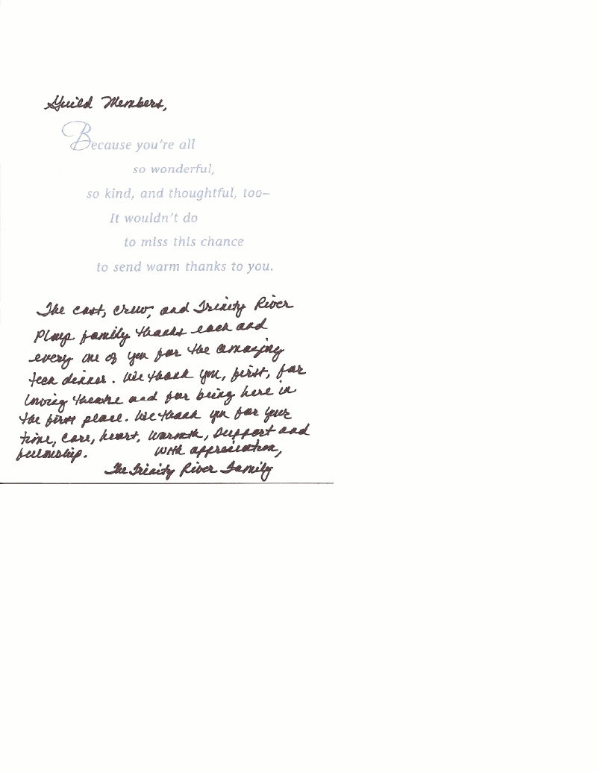
Calendar of Events (see the web site for a complete listing)

General Meeting – Monday, January 31
Contact Fran Burke: 214-522-2953

Executive Board Meeting – Thursday, January 20, 11:30 a.m., Kalita Humphreys Theater

Tech Dinner – January 30, 4:30 p.m., and March 6, 4:30 p.m.
Contact Ruda Anderson: 214-280-7178 or Rosemarie Marshall: 214-770-6165
(Email will be sent out)

Meet-and-Greet (Dividing the Estate) – Tuesday, February 8, 11:00 a.m., Wyly Theatre
Contact Sherry Peel: 214-728-2006

First Sunday – To be determined

Postscript

Tech Dinners – The Dallas Theater Center Guild Tech Dinners for October and November were very successful with 36 crew members attending the October 31st “Halloween” dinner for Rain and 80 members attending the November 21st A Christmas Carol dinner. The cast and crew always look forward to the home-cooked meals provided and a welcomed break in their rehearsal schedule. Appreciation is always expressed to committee members for both the quality and quantity of food served. Guild volunteers are able to share the meal with the cast and have the opportunity to “look behind the scenes” of each production. Please contact Ruda Anderson or Rosemarie Marshall and join the volunteers of this rewarding activity.
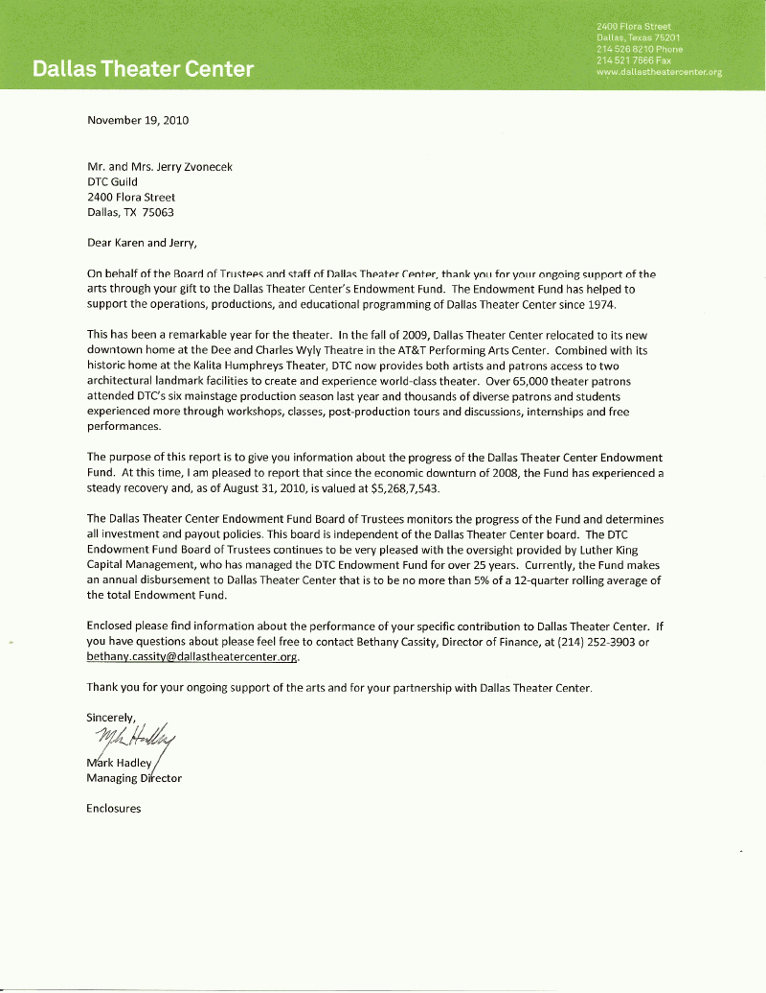
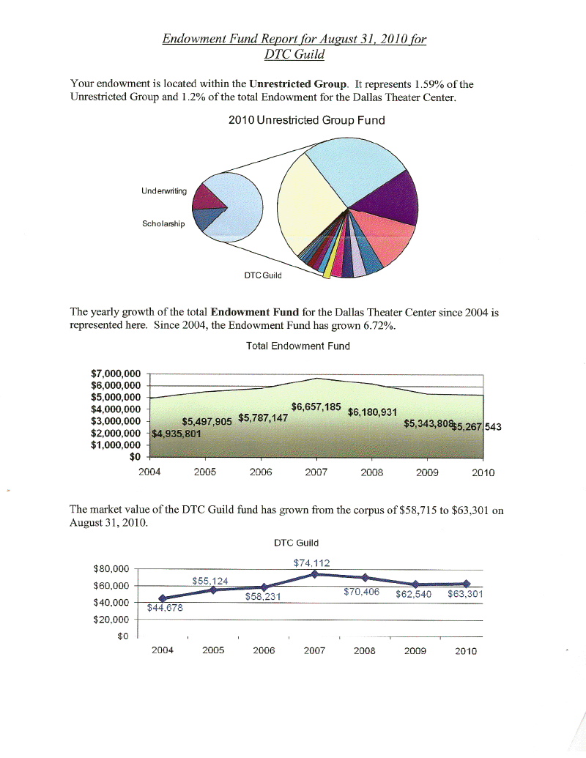

Membership News

A warm welcome to our new members!

Madeline and Michael Freberg
2815 Amherst Ave.
Dallas 75225
(h) 214 234-7699 (c) 214 934-1776
frebergm@bellsouth.net

Nancy Herman
6517 Malcolm Dr.
Dallas 75214
214 823-7083

Sylvia and David Kidd
1723 Vicksburg Dr.
Mesquite 75181
972 222-7088

Address Correction:

Nan-Elizabeth Byorum
6060 Forest Lane
Dallas 75230

Sue Prather

Sue Prather has been hospitalized at Baylor with a fractured vertebra. Her doctors have requested no visitors or phone calls for now — sleep and rest to heal!

Joan Flatt

Joan Flatt is recovering at home after a fall.
DTC Guild Christmas Party at Sarah Warnecke’s Beautiful home!

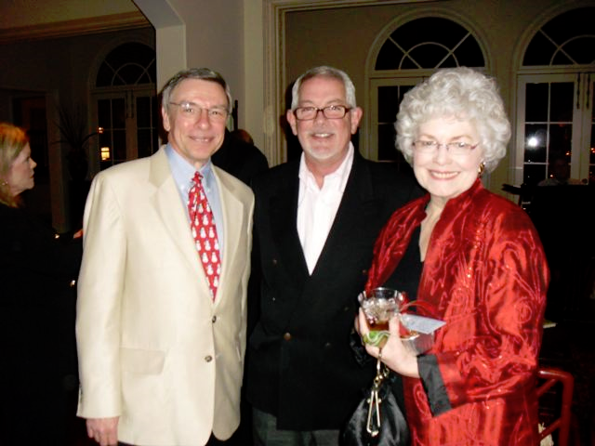
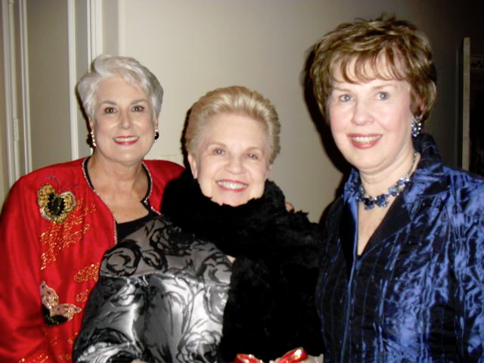

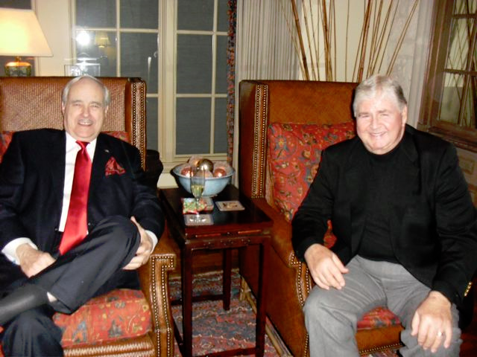
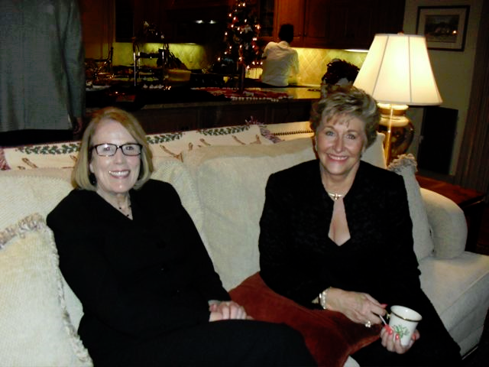

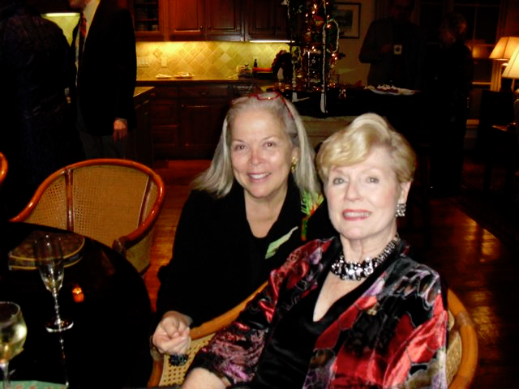
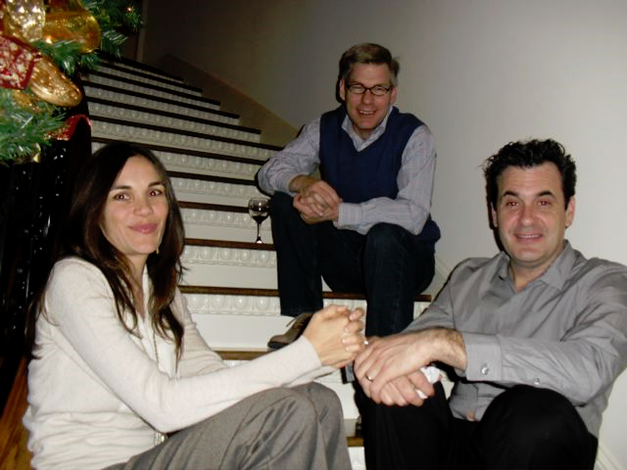

Dallas Theater Center Guild

DTC Guild Newsletter is published approximately four times a year. Email photos and articles to hlboehning@gmail.com

The next newsletter will be around Apr. 2011.
Newsletters also posted on the website.

www.dtcguild.org



DTC 2010-2011 Guild Executive Board

President – Jerry & Karen Zvonecek
Co-Presidents Elect – Sherry Peel, Vicki Newsom
VP Finance – Sam McKenney
VP Membership – Nancy Ritter
VP Publications – Sarah Warnecke
VP Social Arrangements – Fran Burke, Susan Falvo
VP Theater Services – Judy Mathis
Recording Secretary – Brenda Truitt
Corresponding Secretary – Pat Pace
Historian – Giana DePaul

3717 Guadalajara Court
Irving, TX 75062

